中国科学院长春应用化学研究所
应 用 化 学 学 术 讲 座
报 告 人 | Prof. Thomas P. Russell |  | 建 议 人 | 韩艳春
Polymer Science and Engineering Department, University of Massachusetts, Amherst, MA 01003, USA.  russell@mail.pse.umass.edu |  |  | 报告时间 | 2011.09.08 9:00
 |  |  | 报告地点 | 主楼410
 |  |  | 主 持 人 | 景遐斌
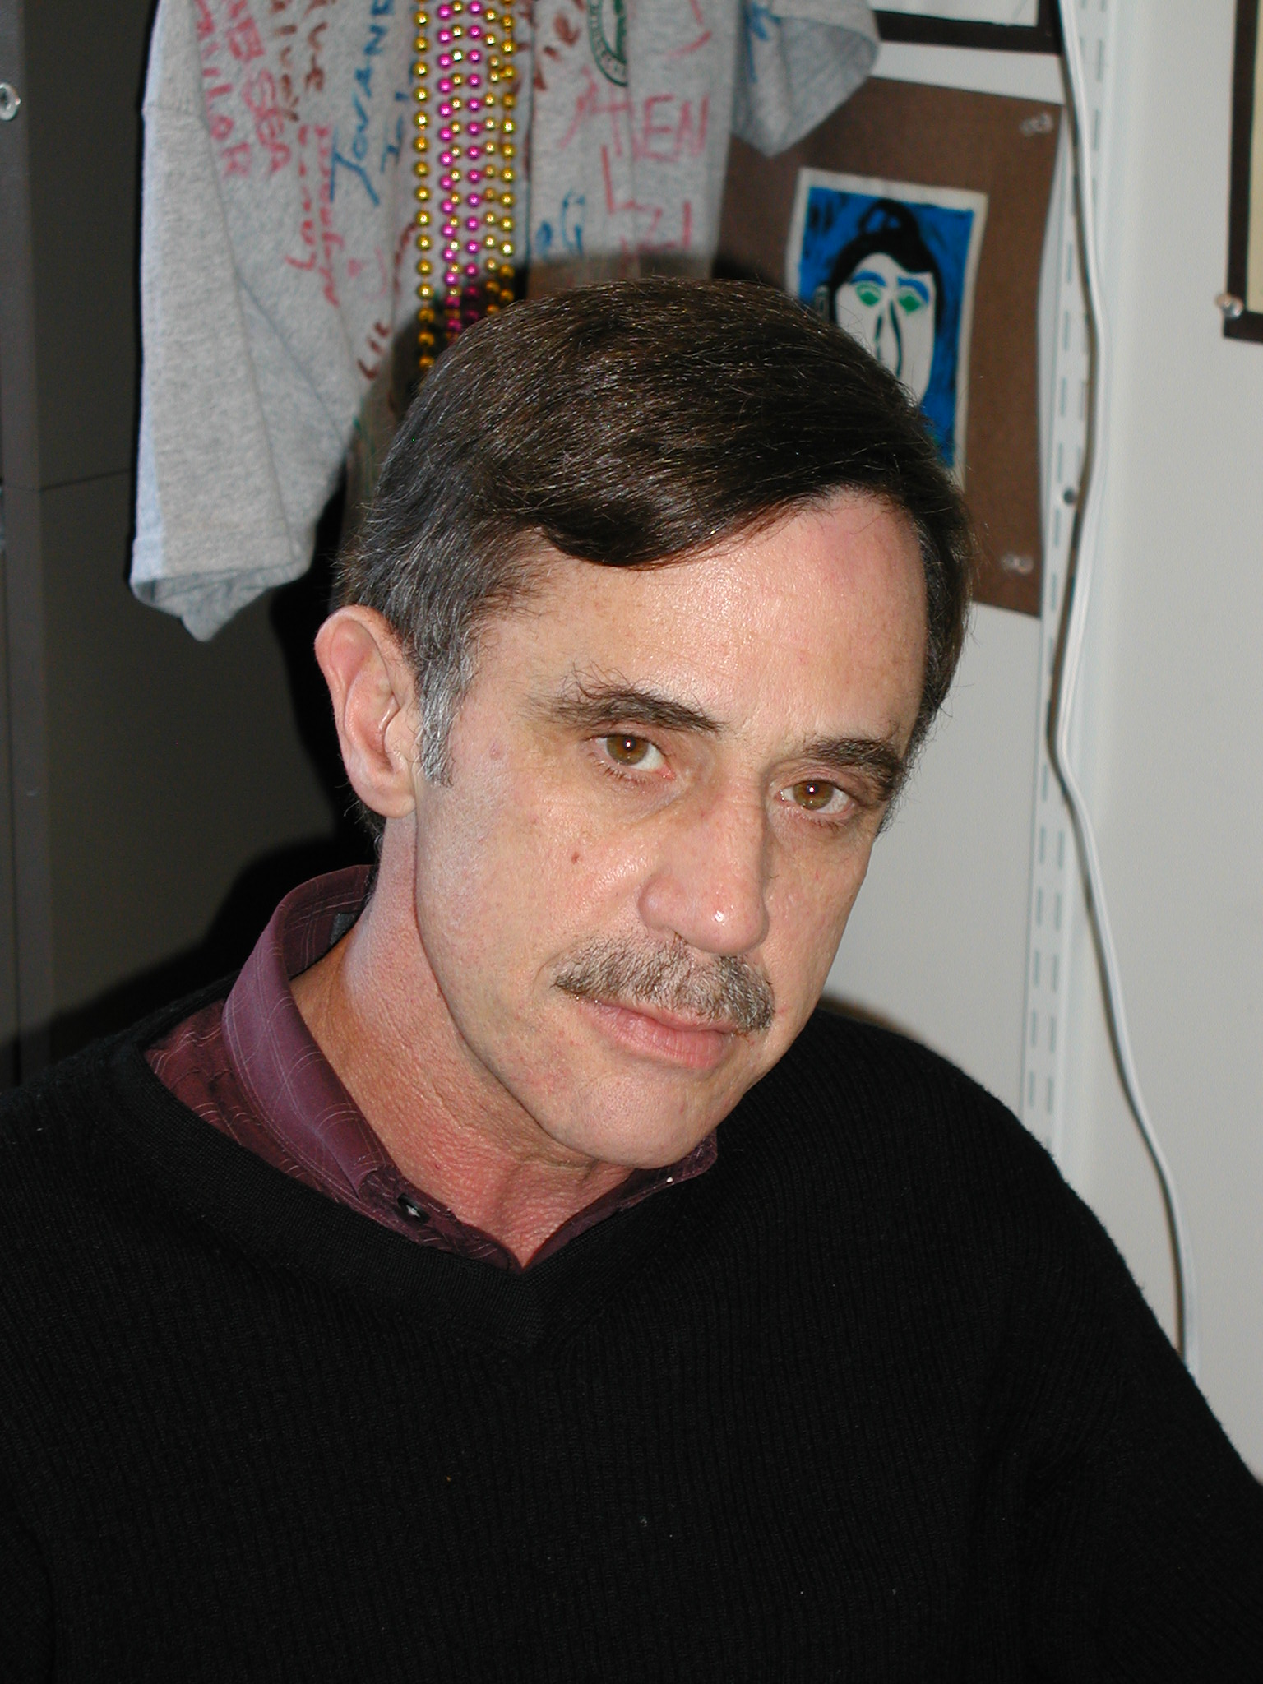 |  | The Silvio O. Conte Distinguished Professor of Polymer Science and Engineering, received his PhD in 1979 in Polymer Science and Engineering from the University of Massachusetts Amherst. He was a Research Staff Member at the IBM Almaden Research Center in San Jose, CA (1981-96) and became a Professor of Polymer Science and Engineering at the University of Massachusetts Amherst (1997). His research interests include the surface and interfacial properties of polymers, phase transitions in polymers, directed self-assembly processes, the use of polymers as scaffolds and templates for the generation of nanoscopic structures, the interfacial assembly of nanoparticles, dynamics in polymer thin films, and wrinkling and crumpling behavior of thin polymer films. He currently has over 500 publications and 12 patents dealing with is research. He is the Director of the Energy Frontier Research Center on Polymer-Based Materials for Harvesting Solar Energy, and an Associate Editor of Macromolecules. He is a fellow of the American Physical Society, the American Association for the Advancement of Science, the Materials Research Society, the Polymer Materials Science and Engineering Division of the ACS and the Neutron Scattering Society of America. He is also a member of the National Academy of Engineering.
报告题目 | ROUTES TO ADDRESSABLE MEDIA OVER MACROSCOPIC
A novel process to prepare highly oriented and aligned dot and line patterns over arbitrarily large surface areas using the self-assembly of block copolymers (BCPs) without the use of photolithography, e-beam lithography, or other process used to chemically or topographically pattern a surface. BCP self-assemble into a range of highly-ordered morphologies and by controlling the orientation and lateral ordering of the nanoscopic microdomains, numerous applications will emerge. By combining confinement effects with the highly directional field inherent in solvent evaporation and the mobility imparted to the BCP by the solvent, perfectly registered arrays of hexagonally packed BCP microdomains can be produced on surfaces at least 3x3 cm² in area with areal densities in excess of 10 terabit/inch². Registry of the arrays and the perfection of the ordering over macroscopic distances were demonstrated by grazing incidence small angle x-ray scattering and scanning force microscopy. Highly aligned and oriented line patterns based on BCP are also of interest, since they overcome a size limitation facing current lithographic technique. However, due to structural imperfections of BCP such as grain boundaries, dislocations, or disclinations, it has been thought near impossible to obtain the well-defined line patterns with high degree of straightness on conventional substrate. Using the faceted surface of reconstructed sapphire or its replica on a flexible polymer, both having a saw tooth patterned surface,a significant enhancement of degree of straightness in line patterns oriented normal to the ridges of the facets on the surface was obtained. With PS-b-PEO, force microscopy demonstratedthat highly aligned PEO cylindrical microdomains oriented parallel to the surface and normal to the surface facets were obtained over the entire surface. Grazing incidence small angle x-ray scattering (GI-SAXS) and 2D transmission SAXS were performed to characterize the ordering on the nanoscopic level over macroscopic length scales. X-ray results indicated that this film consisted of highly aligned and oriented cylindrical microdomains with no grains or mis-orientation over large areas owing to the ability of the faceted surfaces to direct the assembly of the block copolymer. In fact, perfect line patterns were obtained on the faceted surfaces even though there was a distribution of facet pitches and amplitudes. Applications of these materials for scalable nano-manufacturing processes will be discussed.

*Work done in collaboration with Sung Woo Hongª, Dong Hyun Leeª, SoojinPark^{b} and Ting Xu^{ca}Department of Polymer Science and Engineering, University of Massachusetts, Amherst, MA 01003, USA, ^{b} School of Energy Engineering, Ulsan National Institute of Science and Technology, 100 Banyeon-ri, Eonyang-eup, Ulju-gun, Ulsan, Korea 689-805, ^{c}Department of Materials Science and Engineering, Department of Chemistry, University of Berkeley, and Material Sciences Division, Lawrence Berkeley National Laboratory, Berkeley, CA 94720, USA

